**Cyber Security – Assessment # 9**

**Q1**. Steganography is the practice of hiding a secret message inside ordinary digital files like images, videos, or audio so that no one notices the message is there. Unlike cryptography, which hides the content of a message, steganography hides the existence of the message itself.

* Hide a secret text message inside jpeg image using “steghide”. Set appropriate passphrase. Extract the same message. Repeat the same task using “stegosuite”.
* Hide a secret text message inside jpeg image using “WinRAR” in windows based environment. Carry out extraction process.
* Hide a executable ( bat file ) in jpeg image. Use “WinRAR” in windows environment. Verify, once steg file is execute, it executes the code in defined order.
* Hide a secret text message inside mp3 audio carrier using “Deep Sound”. Encode secret files using appropriate encryption scheme. Extract the message.
* Hide a secret text message in MP4 video using “Openpuff”. Encode and verify by extracting the same.

**Answer**

Steganography is a fascinating technique for hiding information within digital media, and there are several tools available to accomplish this. I'll provide an overview of how each method works:

**1. Hiding a Secret Text Message inside a JPEG Image**

**Using Steghide**

* Install Steghide if not already installed (it works on Linux and Windows).
* Embed the secret message into the image using the following command:
  + steghide --embed -cf image.jpg -ef secret.txt
* To extract the secret message, use:
  + steghide extract -sf image.jpg

**Using Stegosuite**

* Open Stegosuite and load your JPEG image.
* Add your secret text and set a passphrase.
* Save the modified image and verify the hidden data.
* To extract, reopen the modified image in Stegosuite and enter the passphrase.

**2. Using WinRAR for Steganography in Windows**

**Hide a Secret Text Message**

* Put your secret text file into a folder.
* Compress it into a .rar archive.
* Use the following command in Command Prompt:
  + copy /b image.jpg + secret.rar output.jpg
* The file still appears as an image but contains the hidden RAR archive.
* To extract, rename output.jpg to output.rar and open it with WinRAR.

**3. Hiding an Executable (.bat File) in a JPEG Image (Windows)**

* Convert the .bat file into a RAR archive.
* Use the same **copy /b** method to append it to a JPEG image.
* When executed in a batch file, use:
  + start output.jpg
* This can invoke the executable hidden inside.

**4. Hiding a Secret Message inside an MP3 File Using DeepSound**

* Open DeepSound and load an MP3 file.
* Select secret files to embed, choose encryption, and set a password.
* Save the modified MP3 file.
* To extract, load it again in DeepSound and enter the password.

**5. Hiding a Secret Message inside an MP4 Video Using OpenPuff**

* Open OpenPuff and select the video file as the carrier.
* Add the secret file and set encryption parameters.
* Save the modified video file.
* To retrieve the hidden content, reopen it in OpenPuff and enter the decryption keys.

**Kali Linux (Steghide Tool)**

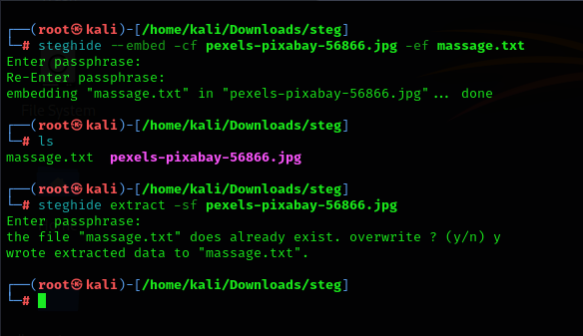

**Windows (hide massage.txt file in image)**

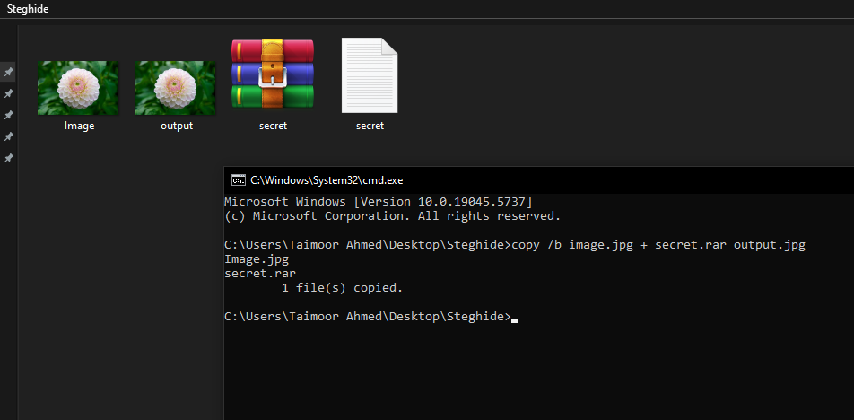

**Windows (hide massage.txt file in video/audio using “DeepSound or OpenPuff”)**

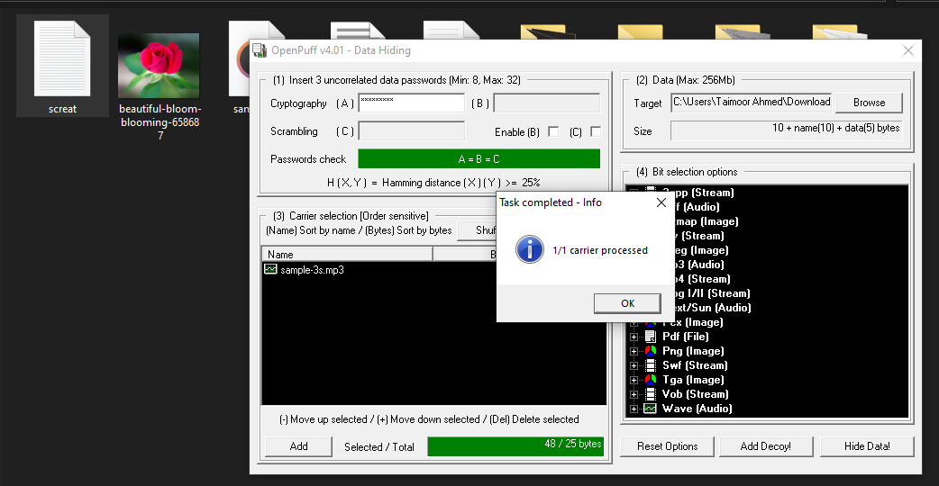

**Windows (unhide massage.txt file in video/audio using “DeepSound or OpenPuff”)**

